LOVETT ELEMENTARY SCHOOL
HOUSTON INDEPENDENT SCHOOL DISTRICT
SDMC MEETING AGENDA
September 15, 2016

SDMC Meeting Schedule
16-17 Schedule proposed: September, October, November, January, February, March, and April-3rd Thursday of each month

School Updates:
Budget:
- Enrollment projected at 679 students, current enrollment is 666 students; will payback if enrollment not met
  - PTO voted to take on some school expenses to help our general budget stretch further
Accountability 2016: Lovett received 6/6 STAARS earning distinctions in all areas
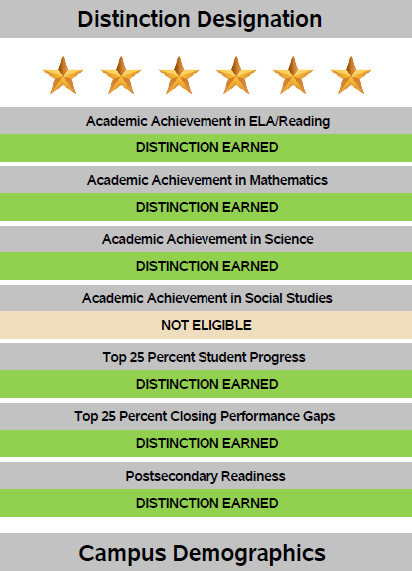

School Goals 15-16
The percentage of students with satisfactory performance on STAAR reading was 94%, Math was 92%, and writing scores showed a 7% increase from 83% in 2015 to 90% in 2016. Beyond students meeting expectations 70% of Lovett students meet or exceed growth expectations. In addition we see consistent evidence of closing the performance gap. Our African American student overall showed a 4% increase and our Hispanic student population met standards at a rate of 89% as compared to 94% of White students. In 15-16, 59% of our students met the post-secondary readiness standard by scoring at the recommended level on STAAR. Additionally, we note less of an achievement gap in this area; 46% of our African American students met this standard as compared to the 59% of all students and 50% of Hispanic students.
Apart of Lovett focus has been to increase rigor in the classroom as one means of moving more students to achieve advanced passing rates. Over the last two years, while we have seen increases in the percentage of students scoring at the advanced level, we fluctuate from year to year, not continuing the trend. Advanced rates were as follows:
- 3rd Reading 46% to 47% 3rd Math 33%
- 4th Reading 40% to 34% 4th Math 38%
- 5th Reading 52% to 40% 5th Math 39% 5th Science 30% to 19%
***Note Reading ADV goal was 57% overall, Math 40% overall
2016-17 Proposed Goals:
- In the 16-17 school year the percentage of students scoring at the ADV level on STAAR Reading will increase from 40% to 55%
- In the 16-17 school year the percentage of students scoring ADV on STAAR math will increase from 40% to 50%
- In the 16-17 school year the average daily attendance rate will increase from 97.3% to 98.5%
- 100% of discipline situations in categories I& II will be provided with classroom based intervention
- During the 16-17 school year, Lovett parents will receive weekly communication focused on creating common language around academics and effective school practices
- Increase the percentage of students in the Fit/Fittest category of Fitness Gram
- During the 16-17 school year the percentage of Econ. Disadvantaged students scoring ADV on STAAR from 22% to 32% on STAAR Reading and 21% to 31% on STAAR math

Important Date Reminders: Next meeting October 20th based on SDMC approval of proposed meeting dates

